Working Committee 1

Natural gas exploration and production

Chairman: Denis Krambeck Dinelli

June 2015

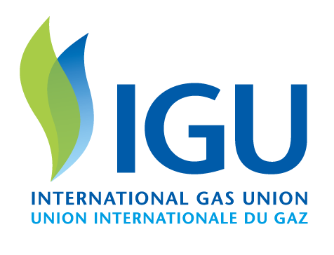
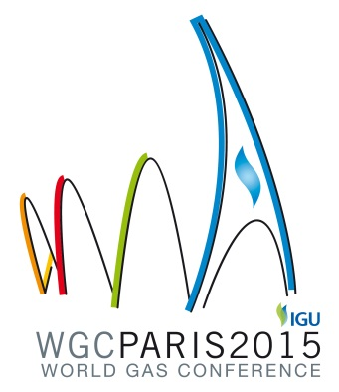
2012-2015 Triennium Work Report
June 2015

Working Committee 1
Natural gas exploration and production
Chairman: Denis Krambeck Dinelli
Secretary: Marcos de Freitas Sugaya

Produced by:
International Gas Union

This document contains strictly technical information to be distributed during the 26th World Gas Conference in Paris, France, and has no commercial intent.
www.igu.org

Abstract

In the current IGU triennium (2012-2015), WOC 1 Natural Gas Exploration and Production selected three themes to develop, having set up three study groups accordingly: (1) Technological advances in gas exploration and production, (2) Assessment of global reserves and resources and (3) Gas rent and mineral property rights.

The first study was motivated by the fact that the production of natural gas has become significantly more expensive over the last years, not only because the new reserves are more difficult to develop than the previous, but also because the cost of the services and products consumed by the industry increased substantially over the last years.

Thanks to the development of new technologies, however, productivity has also improved significantly, and thanks to that gas continues to be one of the most abundant and affordable fuels in the world.

As new opportunities arise, however, new technological frontiers must be consolidated. The study group has covered all such challenges, starting from a revision of the technologies and standards that have become mandatory in the development of upstream projects, aiming at the consolidation of best practices for both conventional and unconventional gas, especially those related with the preservation of the environment.

Building on the list started in the previous triennium, new technologies that have recently emerged via R&D were highlighted and presented according to the conventional life cycle of E&P projects, i.e., exploration, appraisal, development and production.

The second study group promoted an assessment of conventional and unconventional gas reserves and resources. Some of the most important projects under development were described, and their potential impact in the availability of natural gas from both regional and global standpoints was inferred.

Exploratory hotspots and new frontiers were highlighted, and the most important trends, opportunities, uncertainties and threats to be faced by the upstream segment of the gas industry were described and analysed.

The third study group compared some of the most important models in use to balance the interest of upstream investors and governments. Looking at the maximisation of their intakes, governmental regulators must create and maintain an attractive atmosphere for business which will actually develop a win-win situation for themselves and upstream investors.

Concession, sharing, buy-back and transfer of rights contracts have been analysed, together with the large arsenal of fiscal instruments used by regulators and policy makers, including signature bonuses, royalties and taxes on profits of varied nature.

Governments must ensure a proper balance of risks and rewards to promote the development of their projects, but conditions have been found to vary dramatically from country to country.

Topics of interest covered by the study included the identification of regulatory tendencies, the assessment of business models for exploration and production of gas, critical analyses of fiscal instruments and the development of upstream policies for gas rent.

In the end, a number of best practices are described as a means to help the industry, policy makers and regulators in securing a reliable and affordable supply of natural gas to the consumers.

